Software Engineering Platform CMPE 272, group 2:

Tin Tran, Sreedeep Katragadeep, Shiva Kumar Padma, Satish Kumar Gollaprolu

SQL Lite Manager: Here we use a crude design, and some basic SQL queries to create, insert, and drop table

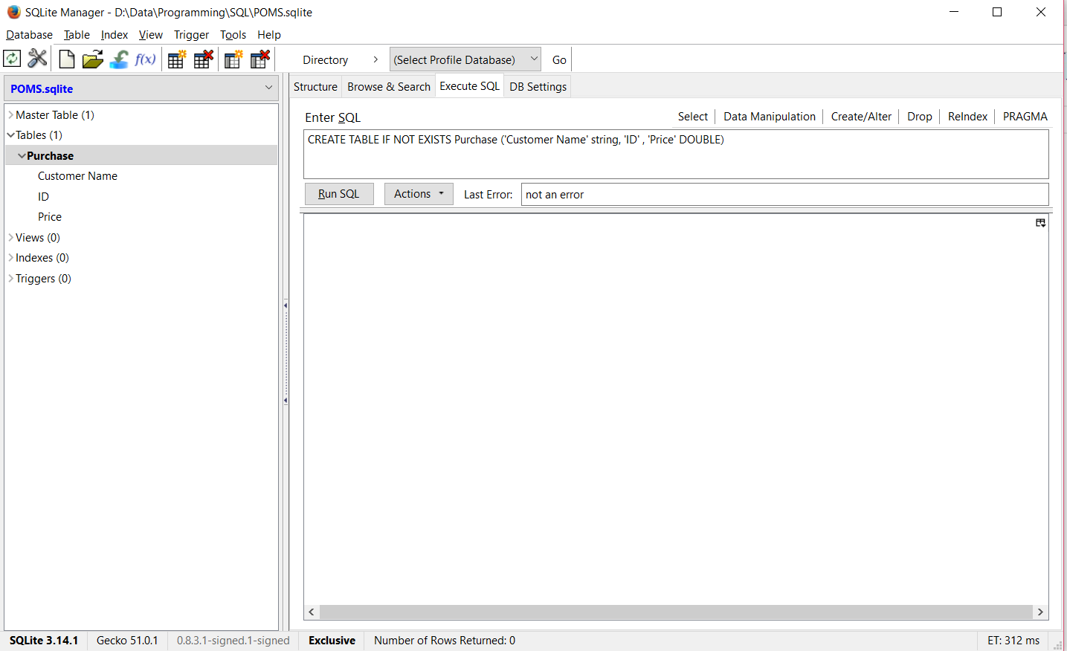

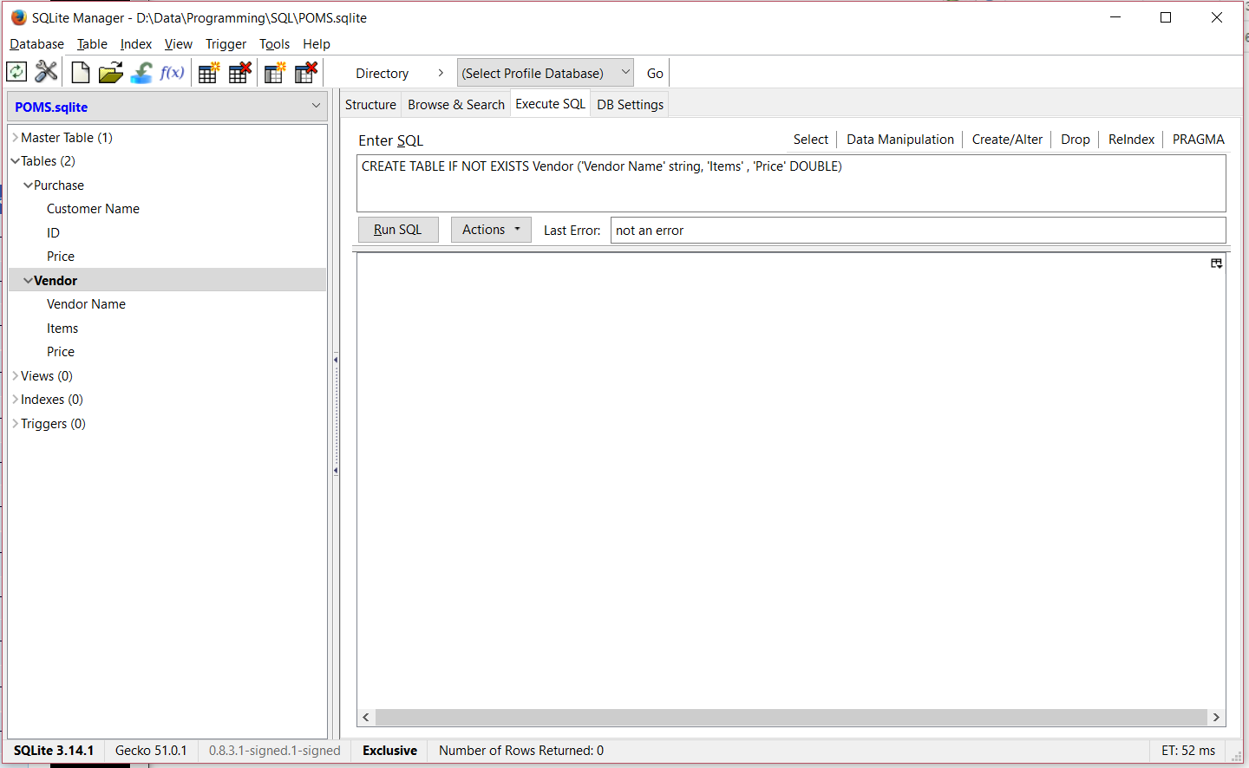

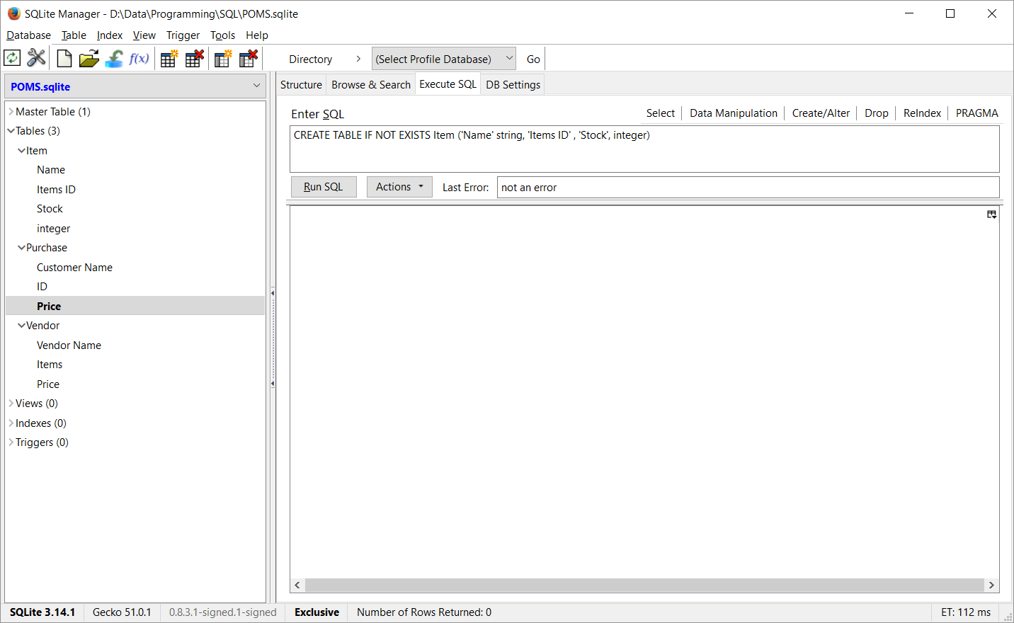

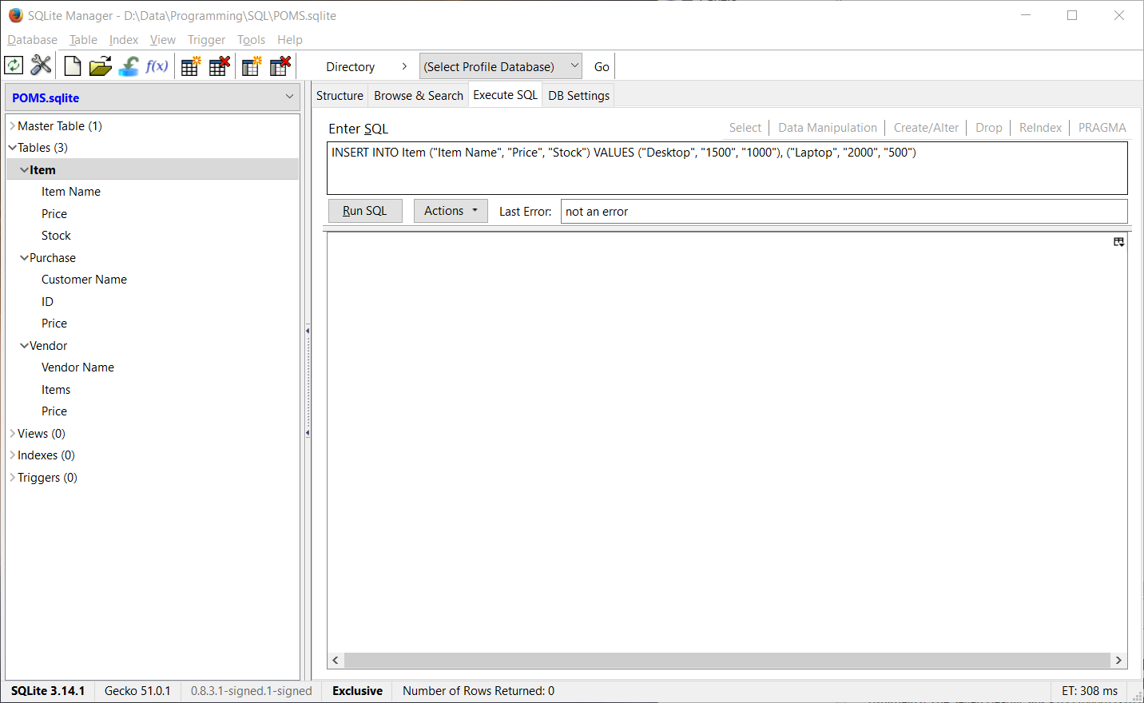

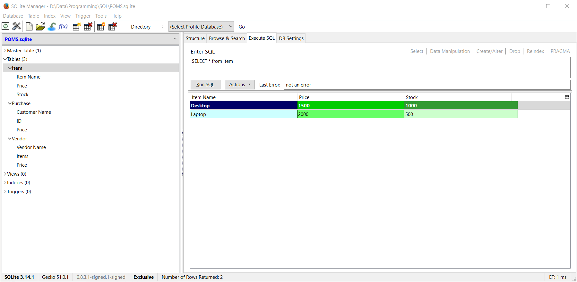

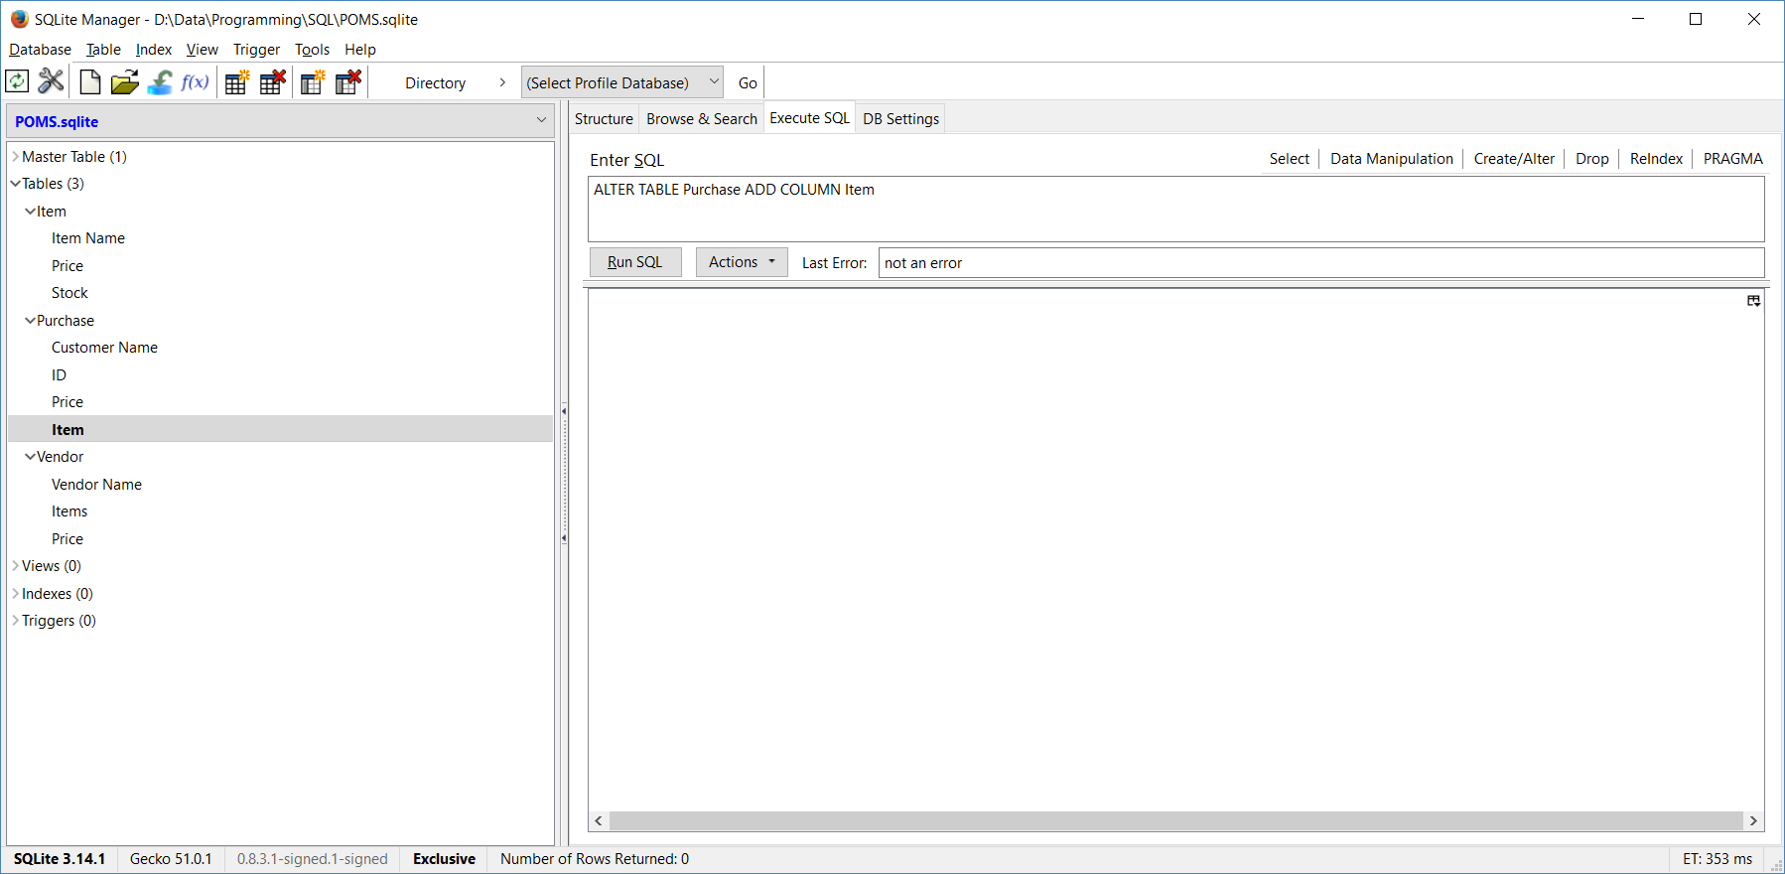

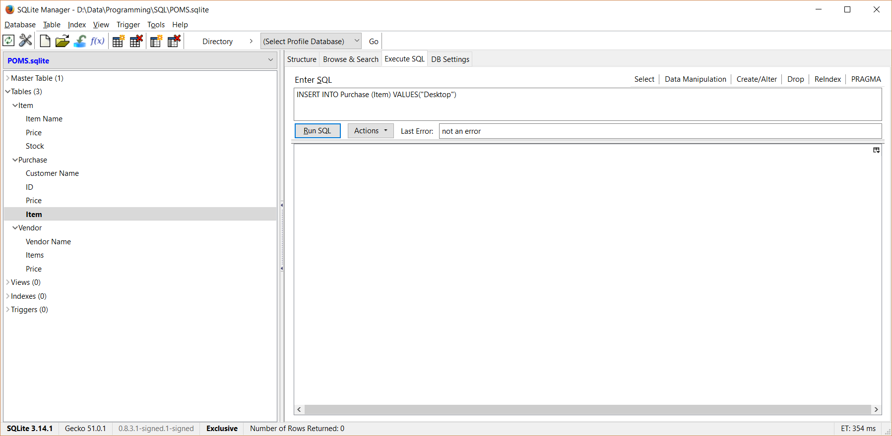

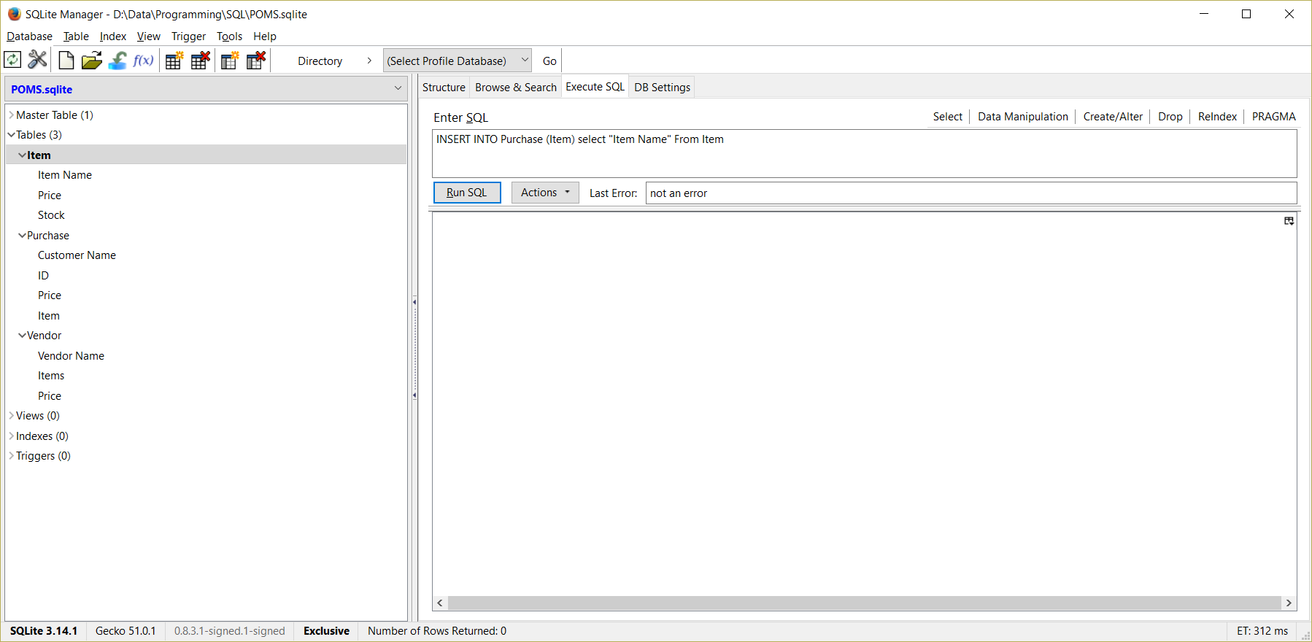

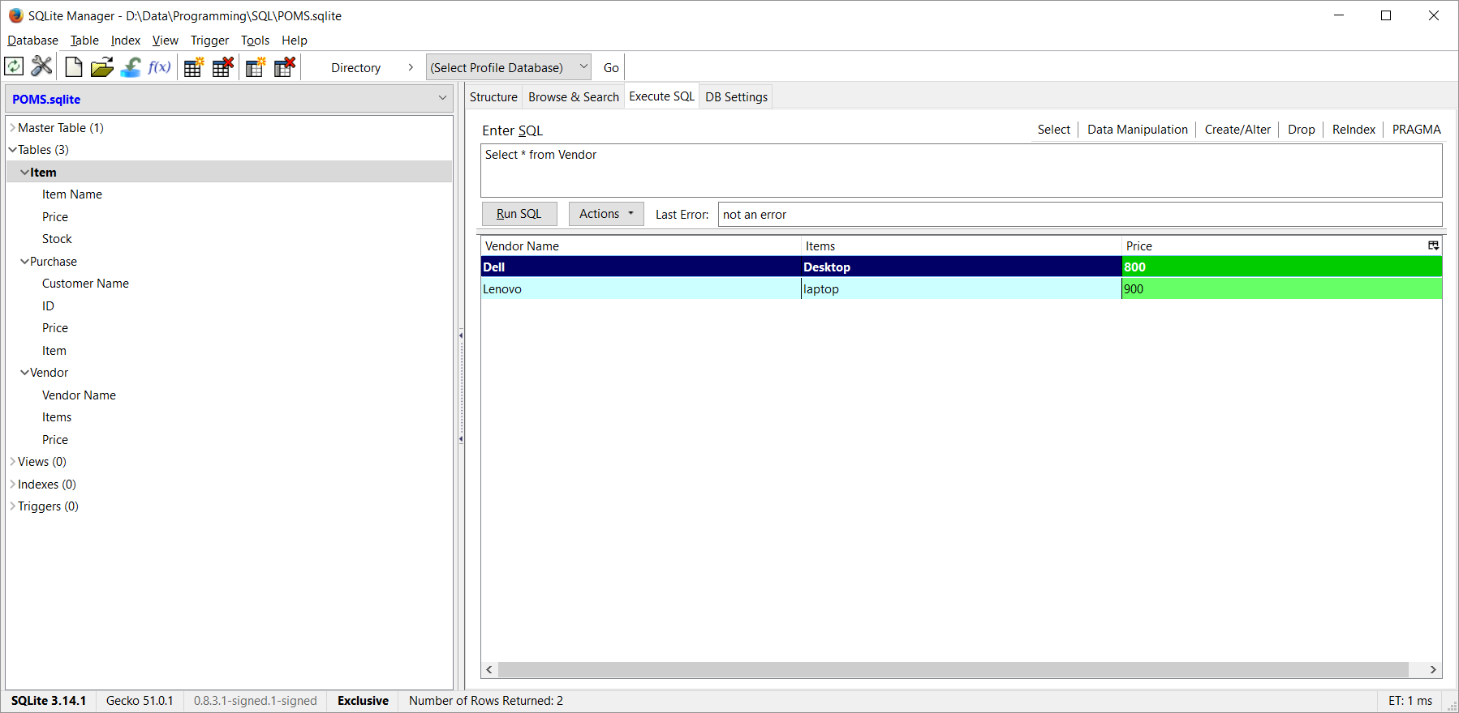

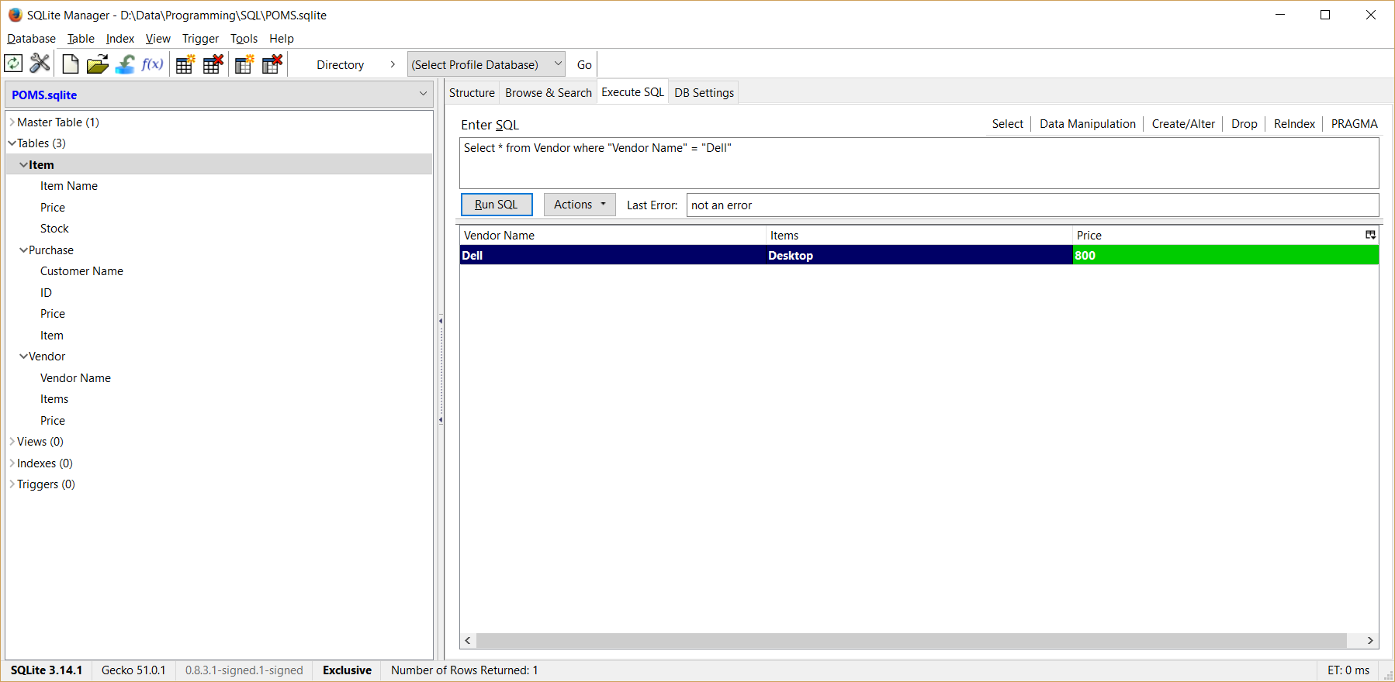

**DB2 Express C:**

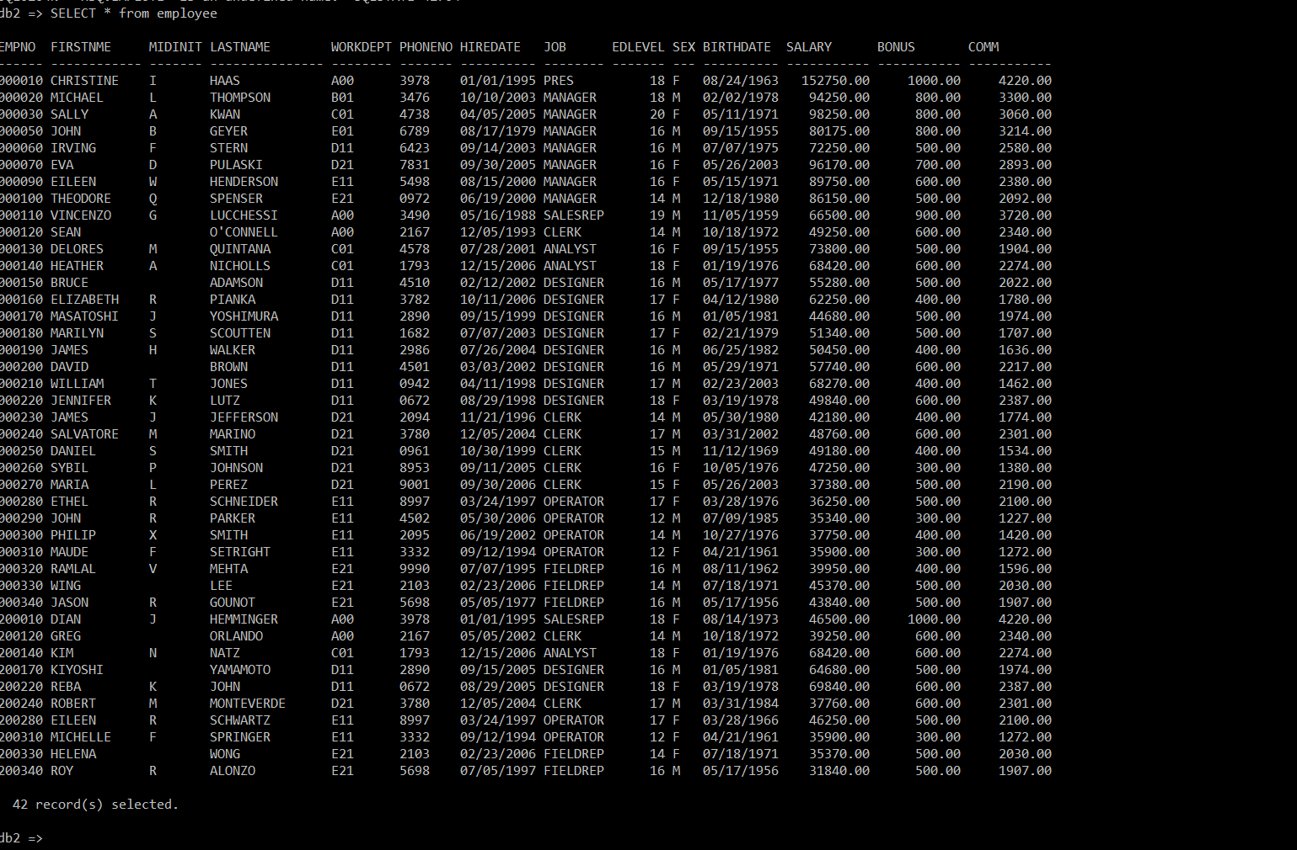

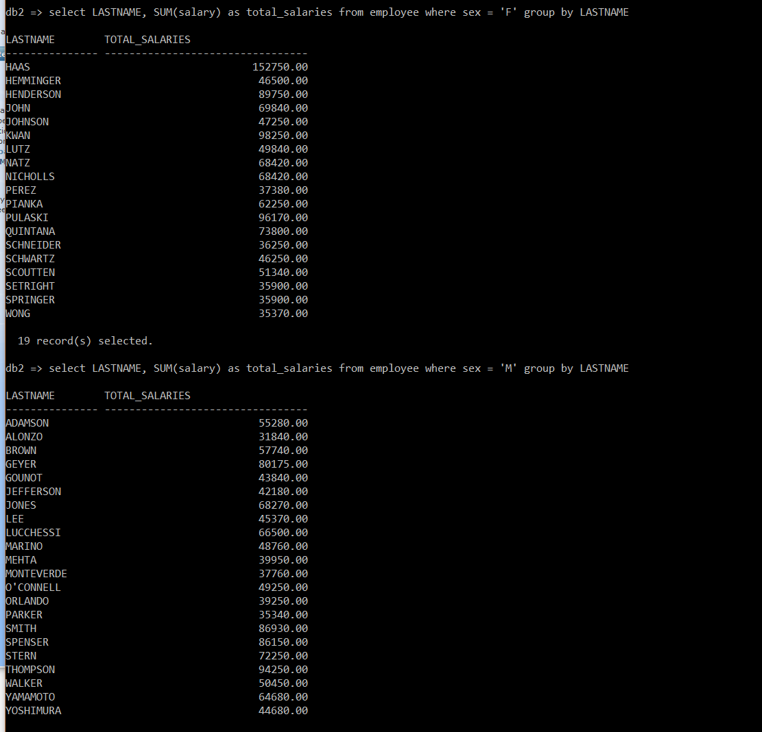

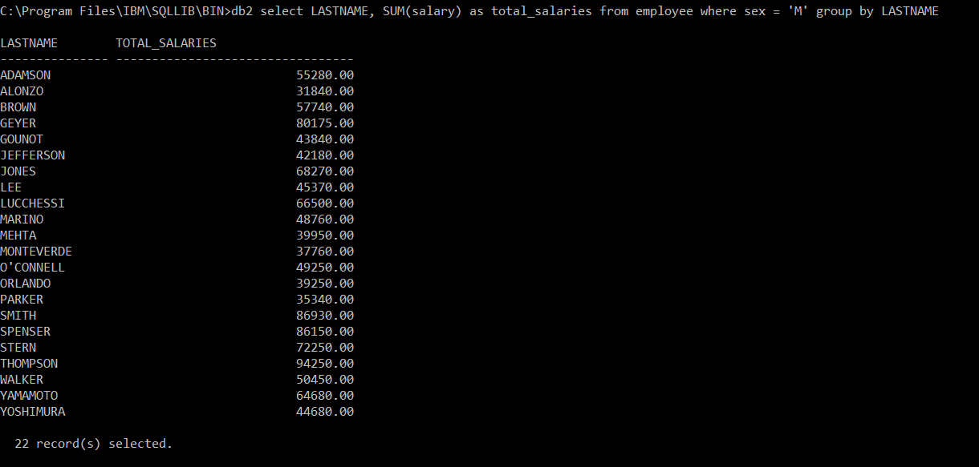

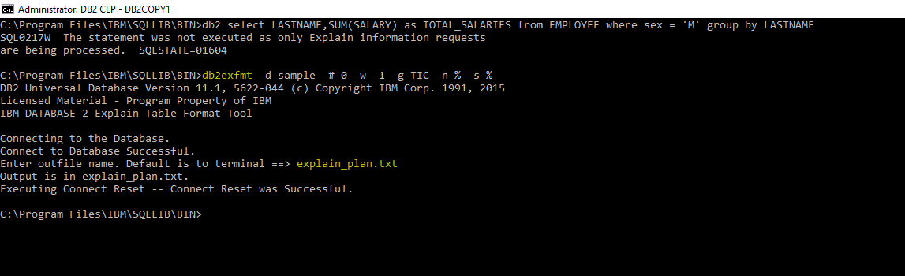

**DB2 Universal Database Version 11.1, 5622-044 (c) Copyright IBM Corp. 1991, 2015**

**Licensed Material - Program Property of IBM**

**IBM DATABASE 2 Explain Table Format Tool**

**\*\*\*\*\*\*\*\*\*\*\*\*\*\*\*\*\*\*\*\* EXPLAIN INSTANCE \*\*\*\*\*\*\*\*\*\*\*\*\*\*\*\*\*\*\*\***

**DB2_VERSION: 11.01.1**

**FORMATTED ON DB: SAMPLE**

**SOURCE_NAME: SQLC2O26**

**SOURCE_SCHEMA: NULLID**

**SOURCE_VERSION:**

**EXPLAIN_TIME: 2017-02-22-15.04.22.083000**

**EXPLAIN_REQUESTER: SHIVA**

**Database Context:**

**----------------**

**Parallelism: None**

**CPU Speed: 1.417033e-007**

**Comm Speed: 0**

**Buffer Pool size: 250**

**Sort Heap size: 256**

**Database Heap size: 600**

**Lock List size: 4096**

**Maximum Lock List: 22**

**Average Applications: 1**

**Locks Available: 28835**

**Package Context:**

**---------------**

**SQL Type: Dynamic**

**Optimization Level: 5**

**Blocking: Block All Cursors**

**Isolation Level: Cursor Stability**

**---------------- STATEMENT 1 SECTION 201 ----------------**

**QUERYNO: 4**

**QUERYTAG: CLP**

**Statement Type: Select**

**Updatable: No**

**Deletable: No**

**Query Degree: 1**

**Original Statement:**

**------------------**

**select**

**LASTNAME,**

**SUM(SALARY) as TOTAL_SALARIES**

**from**

**EMPLOYEE**

**where**

**sex = 'M'**

**group by**

**LASTNAME**

**Optimized Statement:**

**-------------------**

**SELECT**

**Q3.LASTNAME AS "LASTNAME",**

**Q3.$C1 AS "TOTAL_SALARIES"**

**FROM**

**(SELECT**

**Q2.LASTNAME,**

**SUM(Q2.SALARY)**

**FROM**

**(SELECT**

**Q1.LASTNAME,**

**Q1.SALARY**

**FROM**

**SHIVA.EMPLOYEE AS Q1**

**WHERE**

**(Q1.SEX = 'M')**

**) AS Q2**

**GROUP BY**

**Q2.LASTNAME**

**) AS Q3**

**Access Plan:**

**-----------**

**Total Cost: 82.001**

**Query Degree: 1**

**Rows**

**RETURN**

**( 1)**

**Cost**

**I/O**

**|**

**4**

**GRPBY**

**( 2)**

**82.0007**

**12**

**|**

**4**

**TBSCAN**

**( 3)**

**82.0005**

**12**

**|**

**4**

**SORT**

**( 4)**

**82.0001**

**12**

**|**

**40**

**TBSCAN**

**( 5)**

**81.9947**

**12**

**|**

**1000**

**TABLE: SHIVA**

**EMPLOYEE**

**Q1**

**Extended Diagnostic Information:**

**--------------------------------**

**Diagnostic Identifier: 1**

**Diagnostic Details: EXP0020W Table has no statistics. The table**

**"SHIVA "."EMPLOYEE" has not had runstats run on**

**it. This may result in a sub-optimal access plan**

**and poor performance.**

**Diagnostic Identifier: 2**

**Diagnostic Details: EXP0073W The following MQT or statistical view was**

**not eligible because one or more data filtering**

**predicates from the query could not be matched with**

**the MQT: "SHIVA "."ADEFUSR".**

**Diagnostic Identifier: 3**

**Diagnostic Details: EXP0148W The following MQT or statistical view was**

**considered in query matching: "SHIVA "."ADEFUSR".**

**Plan Details:**

**-------------**

**1) RETURN: (Return Result)**

**Cumulative Total Cost: 82.001**

**Cumulative CPU Cost: 2.40636e+006**

**Cumulative I/O Cost: 12**

**Cumulative Re-Total Cost: 0.308176**

**Cumulative Re-CPU Cost: 2.1748e+006**

**Cumulative Re-I/O Cost: 0**

**Cumulative First Row Cost: 82.0004**

**Estimated Bufferpool Buffers: 0**

**Arguments:**

**---------**

**BLDLEVEL: (Build level)**

**DB2 v11.1.1010.160 : s1612051900**

**HEAPUSE : (Maximum Statement Heap Usage)**

**112 Pages**

**PLANID : (Access plan identifier)**

**bf4dea5da30e5f96**

**PREPTIME: (Statement prepare time)**

**61 milliseconds**

**SEMEVID : (Semantic environment identifier)**

**ca3a18197d36bb62**

**STMTHEAP: (Statement heap size)**

**8192**

**STMTID : (Normalized statement identifier)**

**fd3da65ff24a16e3**

**Input Streams:**

**-------------**

**5) From Operator #2**

**Estimated number of rows: 4**

**Number of columns: 2**

**Subquery predicate ID: Not Applicable**

**Column Names:**

**------------**

**+Q4.TOTAL_SALARIES+Q4.LASTNAME**

**2) GRPBY : (Group By)**

**Cumulative Total Cost: 82.0007**

**Cumulative CPU Cost: 2.40414e+006**

**Cumulative I/O Cost: 12**

**Cumulative Re-Total Cost: 0.307861**

**Cumulative Re-CPU Cost: 2.17257e+006**

**Cumulative Re-I/O Cost: 0**

**Cumulative First Row Cost: 82.0004**

**Estimated Bufferpool Buffers: 0**

**Arguments:**

**---------**

**AGGMODE : (Aggregation Mode)**

**FINAL**

**GROUPBYC: (Group By columns)**

**TRUE**

**GROUPBYN: (Number of Group By columns)**

**1**

**GROUPBYR: (Group By requirement)**

**1: Q2.LASTNAME**

**ONEFETCH: (One Fetch flag)**

**FALSE**

**Input Streams:**

**-------------**

**4) From Operator #3**

**Estimated number of rows: 4**

**Number of columns: 2**

**Subquery predicate ID: Not Applicable**

**Column Names:**

**------------**

**+Q2.LASTNAME(A)+Q2.SALARY**

**Output Streams:**

**--------------**

**5) To Operator #1**

**Estimated number of rows: 4**

**Number of columns: 2**

**Subquery predicate ID: Not Applicable**

**Column Names:**

**------------**

**+Q4.TOTAL_SALARIES+Q4.LASTNAME**

**3) TBSCAN: (Table Scan)**

**Cumulative Total Cost: 82.0005**

**Cumulative CPU Cost: 2.40282e+006**

**Cumulative I/O Cost: 12**

**Cumulative Re-Total Cost: 0.307674**

**Cumulative Re-CPU Cost: 2.17126e+006**

**Cumulative Re-I/O Cost: 0**

**Cumulative First Row Cost: 82.0003**

**Estimated Bufferpool Buffers: 0**

**Arguments:**

**---------**

**MAXPAGES: (Maximum pages for prefetch)**

**ALL**

**PREFETCH: (Type of Prefetch)**

**NONE**

**SCANDIR : (Scan Direction)**

**FORWARD**

**SPEED : (Assumed speed of scan, in sharing structures)**

**SLOW**

**THROTTLE: (Scan may be throttled, for scan sharing)**

**FALSE**

**VISIBLE : (May be included in scan sharing structures)**

**FALSE**

**WRAPPING: (Scan may start anywhere and wrap)**

**FALSE**

**Input Streams:**

**-------------**

**3) From Operator #4**

**Estimated number of rows: 4**

**Number of columns: 2**

**Subquery predicate ID: Not Applicable**

**Column Names:**

**------------**

**+Q2.LASTNAME(A)+Q2.SALARY**

**Output Streams:**

**--------------**

**4) To Operator #2**

**Estimated number of rows: 4**

**Number of columns: 2**

**Subquery predicate ID: Not Applicable**

**Column Names:**

**------------**

**+Q2.LASTNAME(A)+Q2.SALARY**

**4) SORT : (Sort)**

**Cumulative Total Cost: 82.0001**

**Cumulative CPU Cost: 2.40029e+006**

**Cumulative I/O Cost: 12**

**Cumulative Re-Total Cost: 0.307315**

**Cumulative Re-CPU Cost: 2.16872e+006**

**Cumulative Re-I/O Cost: 0**

**Cumulative First Row Cost: 82.0001**

**Estimated Bufferpool Buffers: 12**

**Arguments:**

**---------**

**AGGMODE : (Aggregation Mode)**

**PARTIAL**

**DUPLWARN: (Duplicates Warning flag)**

**FALSE**

**KEYS : (Key cardinality)**

**2**

**NUMROWS : (Estimated number of rows)**

**4**

**ROWWIDTH: (Estimated width of rows)**

**41.000000**

**SORTKEY : (Sort Key column)**

**1: Q2.LASTNAME(A)**

**TEMPSIZE: (Temporary Table Page Size)**

**8192**

**UNIQUE : (Uniqueness required flag)**

**FALSE**

**Input Streams:**

**-------------**

**2) From Operator #5**

**Estimated number of rows: 40**

**Number of columns: 2**

**Subquery predicate ID: Not Applicable**

**Column Names:**

**------------**

**+Q2.SALARY+Q2.LASTNAME**

**Output Streams:**

**--------------**

**3) To Operator #3**

**Estimated number of rows: 4**

**Number of columns: 2**

**Subquery predicate ID: Not Applicable**

**Column Names:**

**------------**

**+Q2.LASTNAME(A)+Q2.SALARY**

**5) TBSCAN: (Table Scan)**

**Cumulative Total Cost: 81.9947**

**Cumulative CPU Cost: 2.36232e+006**

**Cumulative I/O Cost: 12**

**Cumulative Re-Total Cost: 0.307315**

**Cumulative Re-CPU Cost: 2.16872e+006**

**Cumulative Re-I/O Cost: 0**

**Cumulative First Row Cost: 8.61685**

**Estimated Bufferpool Buffers: 12**

**Arguments:**

**---------**

**CUR_COMM: (Currently Committed)**

**TRUE**

**LCKAVOID: (Lock Avoidance)**

**TRUE**

**MAXPAGES: (Maximum pages for prefetch)**

**ALL**

**PREFETCH: (Type of Prefetch)**

**NONE**

**ROWLOCK : (Row Lock intent)**

**SHARE (CS/RS)**

**SCANDIR : (Scan Direction)**

**FORWARD**

**SKIP_INS: (Skip Inserted Rows)**

**TRUE**

**SPEED : (Assumed speed of scan, in sharing structures)**

**FAST**

**TABLOCK : (Table Lock intent)**

**INTENT SHARE**

**TBISOLVL: (Table access Isolation Level)**

**CURSOR STABILITY**

**THROTTLE: (Scan may be throttled, for scan sharing)**

**TRUE**

**VISIBLE : (May be included in scan sharing structures)**

**TRUE**

**WRAPPING: (Scan may start anywhere and wrap)**

**TRUE**

**Predicates:**

**----------**

**3) Sargable Predicate,**

**Comparison Operator: Equal (=)**

**Subquery Input Required: No**

**Filter Factor: 0.04**

**Predicate Text:**

**--------------**

**(Q1.SEX = 'M')**

**Input Streams:**

**-------------**

**1) From Object SHIVA.EMPLOYEE**

**Estimated number of rows: 1000**

**Number of columns: 4**

**Subquery predicate ID: Not Applicable**

**Column Names:**

**------------**

**+Q1.$RID$+Q1.SALARY+Q1.LASTNAME+Q1.SEX**

**Output Streams:**

**--------------**

**2) To Operator #4**

**Estimated number of rows: 40**

**Number of columns: 2**

**Subquery predicate ID: Not Applicable**

**Column Names:**

**------------**

**+Q2.SALARY+Q2.LASTNAME**

**Objects Used in Access Plan:**

**---------------------------**

**Schema: SHIVA**

**Name: ADEFUSR**

**Type: Materialized View (reference only)**

**Schema: SHIVA**

**Name: EMPLOYEE**

**Type: Table**

**Time of creation: 2017-02-22-13.53.50.939002**

**Last statistics update:**

**Number of columns: 14**

**Number of rows: 1000**

**Width of rows: 51**

**Number of buffer pool pages: 12**

**Number of data partitions: 1**

**Distinct row values: No**

**Tablespace name: USERSPACE1**

**Tablespace overhead: 6.725000**

**Tablespace transfer rate: 0.080000**

**Source for statistics: Single Node**

**Prefetch page count: 32**

**Container extent page count: 32**

**Table overflow record count: 0**

**Table Active Blocks: -1**

**Average Row Compression Ratio: -1**

**Percentage Rows Compressed: -1**

**Average Compressed Row Size: -1**

**IBM BlueMix graph:**

**Here we use the sample graph data to construct the graph application.**

**We used a bash script to get the token, create a schema, and insert the data to graph application:**

